**Social Media Project Product Launch Campaign**

Batch: AKTI C9 SMM (Gulberg)

Name: Mehreen Naveed

Brand Name: THE WORLD OF CHAI

**LOGO**:



<https://www.facebook.com/chaicart1>

**tagline(bio)**

‘Indulge in the aromatic flavors of our freshly brewed chai straight from our charming Chai Cart. Our Chai Cart services bring warmth and joy to any event or gathering’!

**GOAL**

**Emphasize the unique experience:** " I opened this Chai cart to Treat the community with a unique and delicious chai experience. “And make their events memorable and Glamorous’

**EXAMPLE**

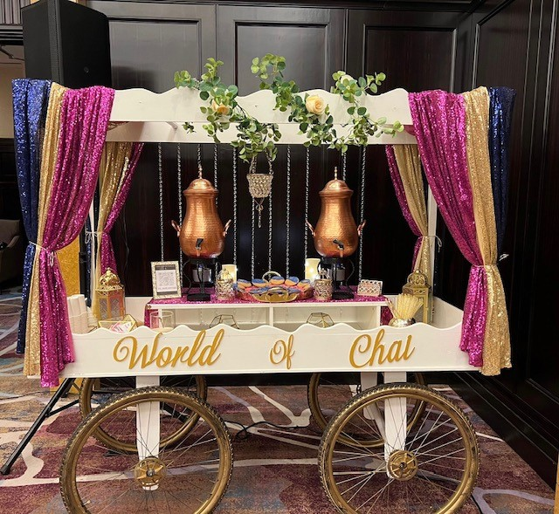

**Facebook Page**

[**https://www.facebook.co**](https://www.facebook.co)

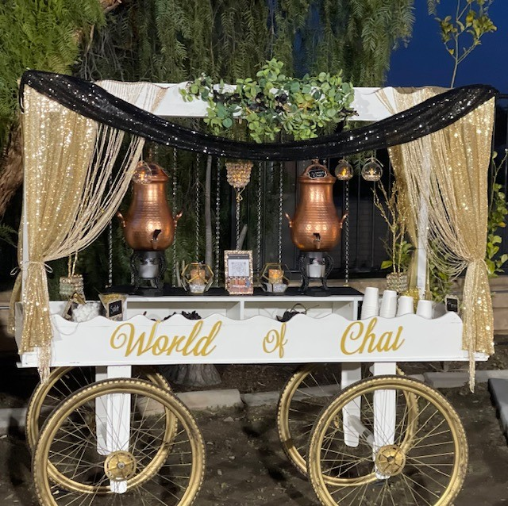

**WEEKLY Schedule template**

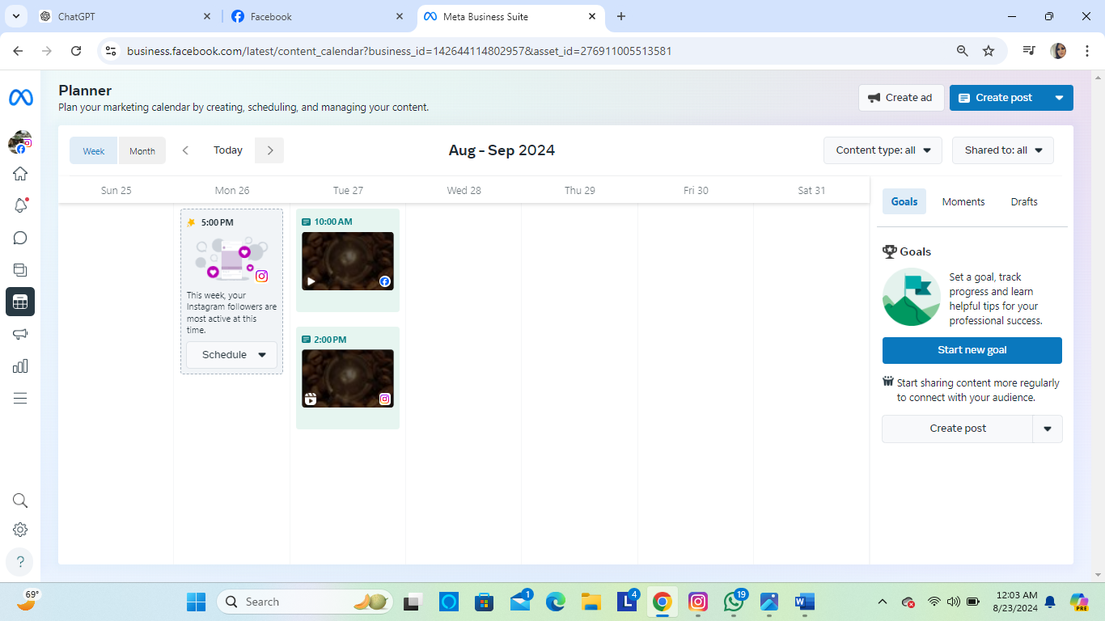

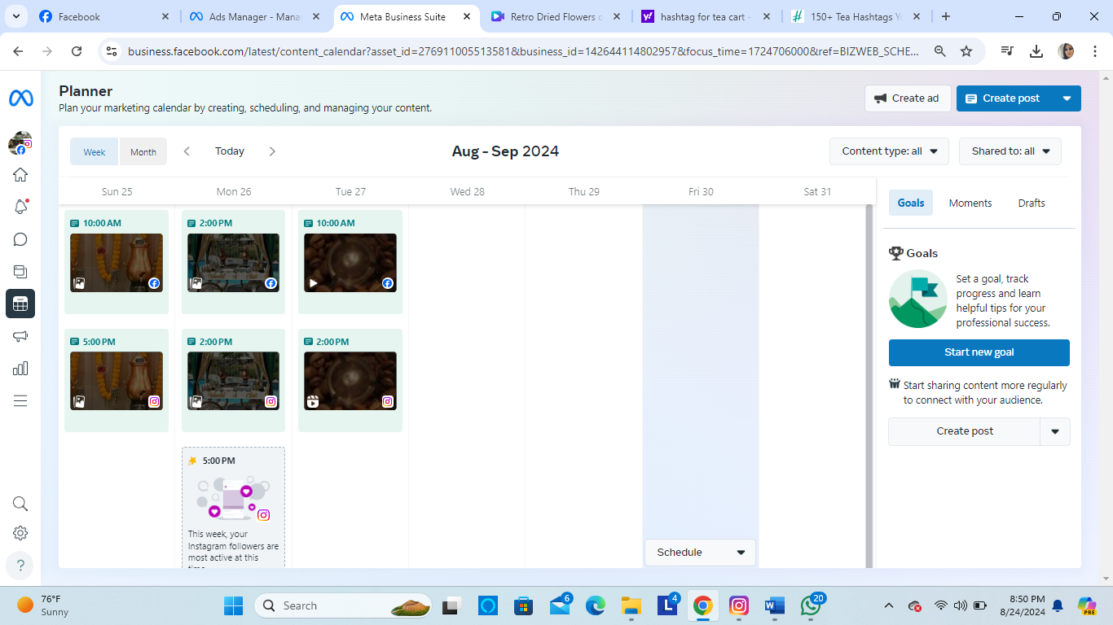

s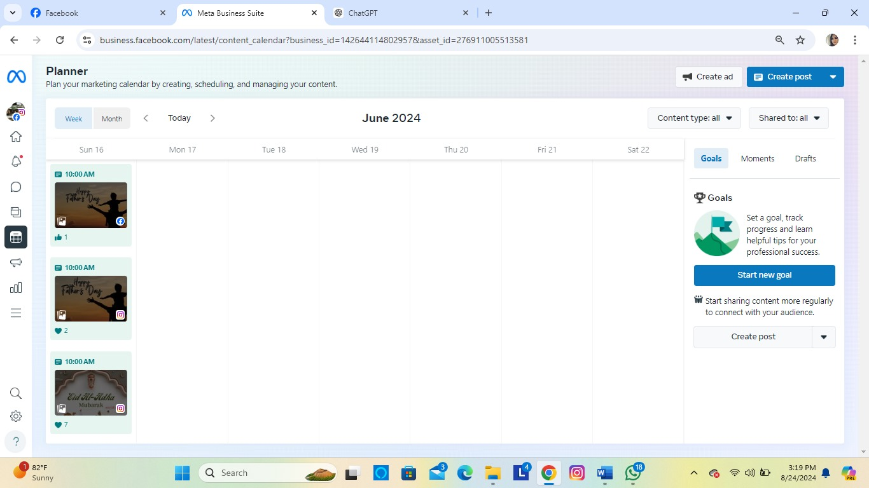

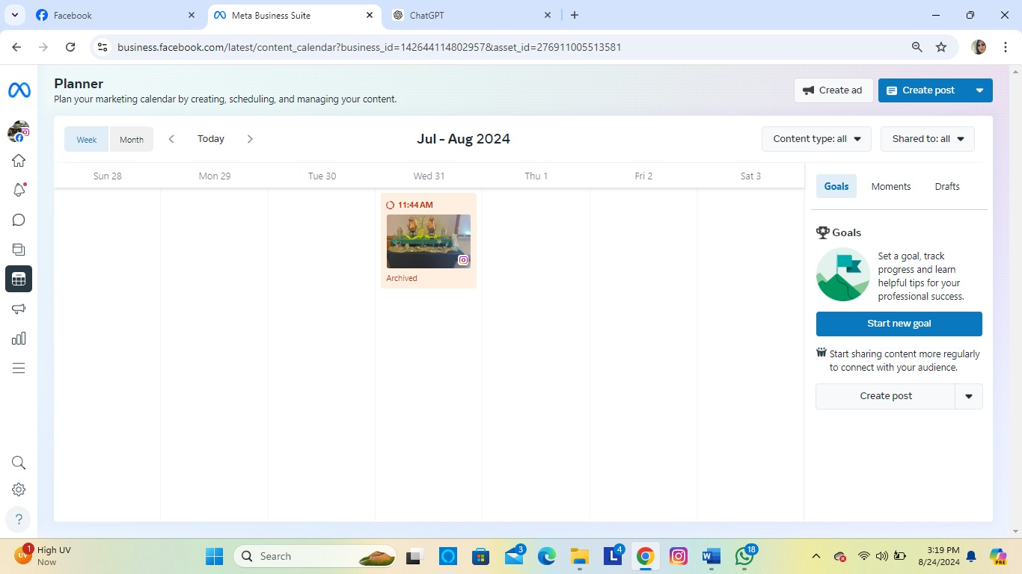

**Post reach &Engagement**

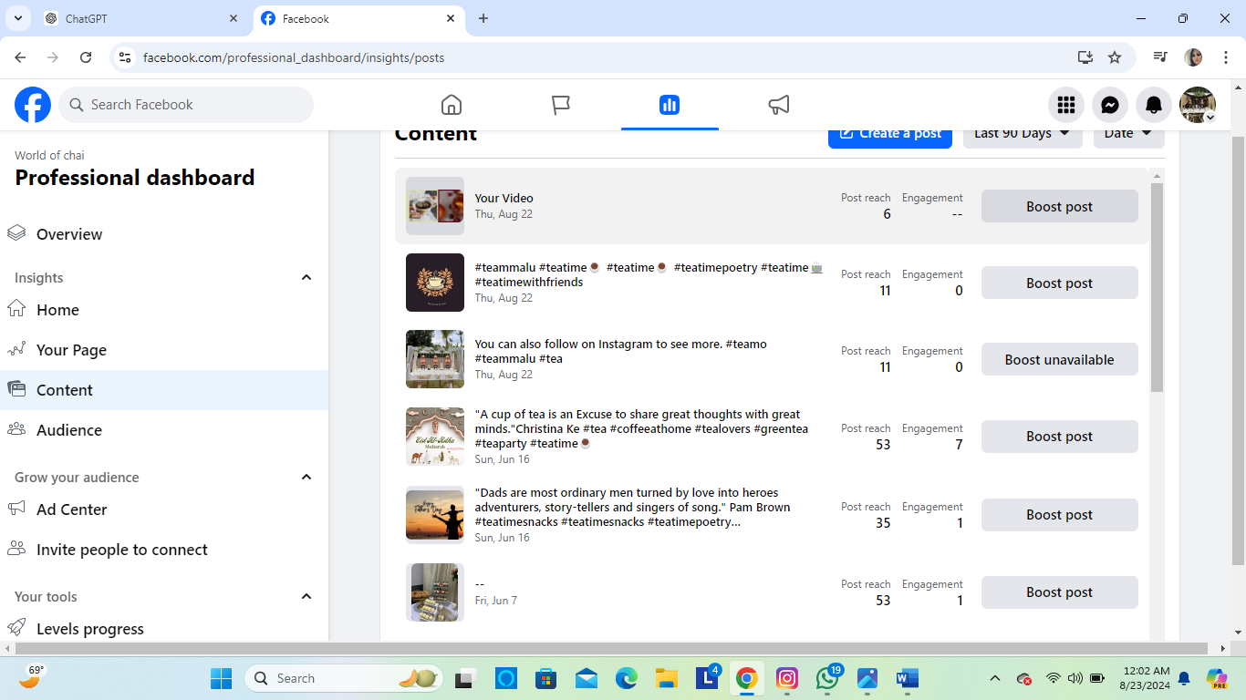

**Here are some key factors to consider when identifying the target audience**

Identifying your target audience is crucial for creating effective social media content. Here are some key factors to consider when identifying the target audience:

**1. Demographics**

• Age**:** 24-45 years old. This range includes students, professionals, and older individuals who might appreciate a quick, convenient tea option.

• Gender**:** Both men and women, as tea has broad appeal across genders.

• Location**:** Areas such as college campuses, business districts. Hotels. The nature of a business needs physical presence, so we cater within 25 kilometers radius

• Income **Level:** Low to middle-income individuals who are looking for affordable yet quality tea options on the go.

**3. Behavioral Factors**

* **Purchasing Habits:** Impulse buyers who see the cart and decide to try it out, as well as regular customers who make it a part of their events. They may be price-sensitive but are looking for good value.
* **Social Media Usage:** While the cart is in a physical location, the target audience might still engage with content on platforms like Instagram or Facebook, especially if the cart has a unique aesthetic or offers specials or loyalty rewards.
* **Engagement:** Likely to engage with promotions, discounts, or special offers. They might also participate in social media contests or share their experience if they find it unique or memorable.
* **Community-Oriented:** Residents often value businesses that feel like part of the community. Participating in local events or offering neighborhood discounts can strengthen this connection.
* **Word-of-Mouth**:
* Residents may recommend your cart to friends and family if they enjoy the experience, so building strong customer relationships is key.
* Audience type
* Primary Audience:
* Students
* Nikah ceremony
* event planners
* Conferences
* Weddings
* birthdays
* Secondary Audience:
* Residents who may engage less frequently still represent an important customer base, especially Young **Families with children**
* Cultural Enthusiasts
* Event Attendees

**AUDIENCE**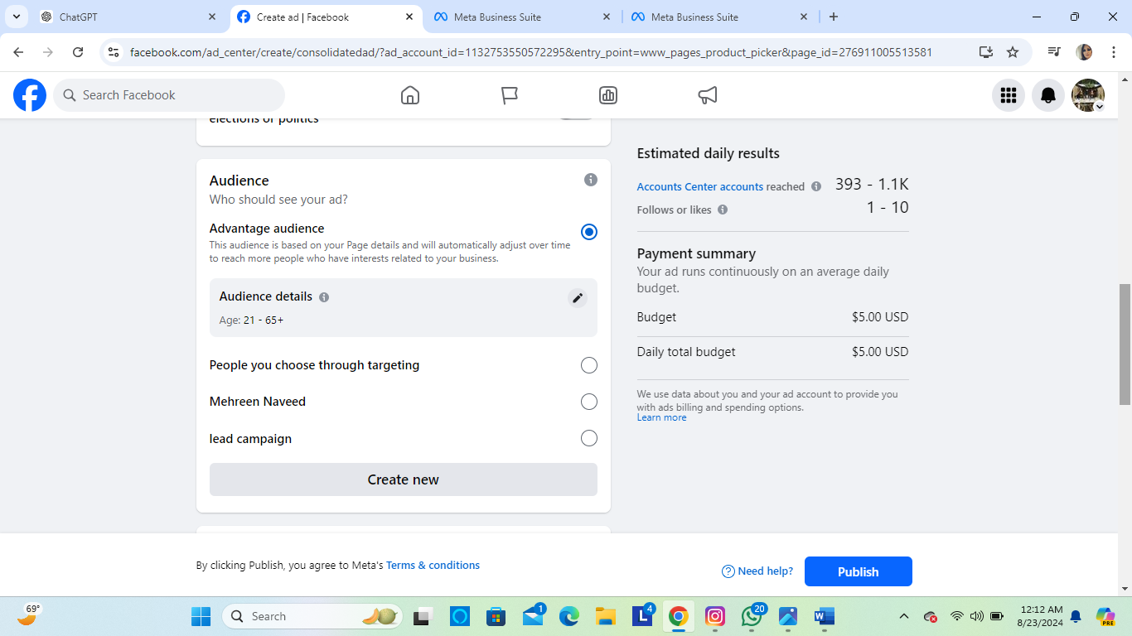

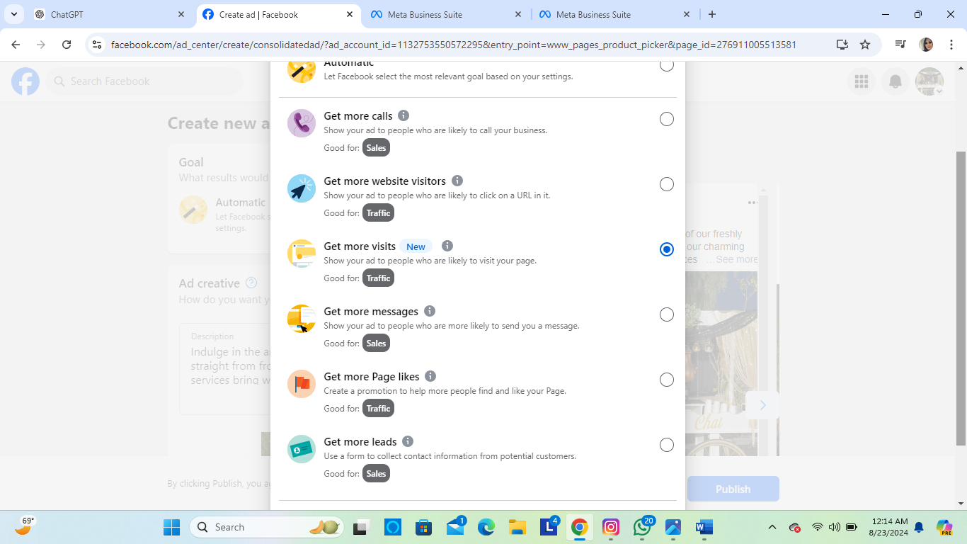

**A/B te**sting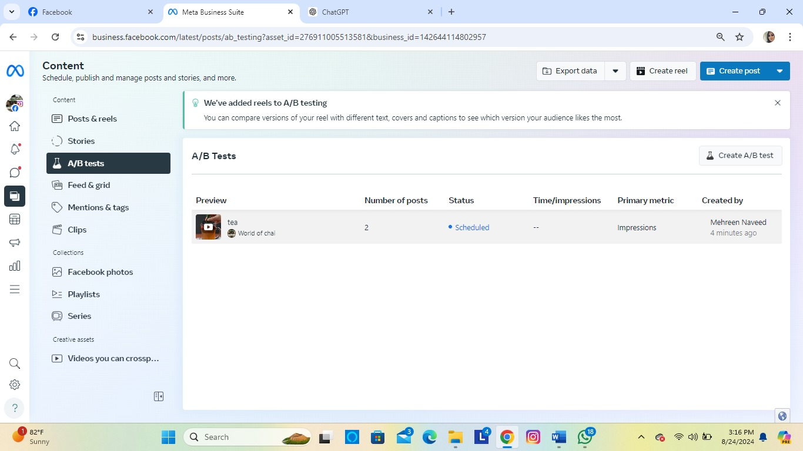

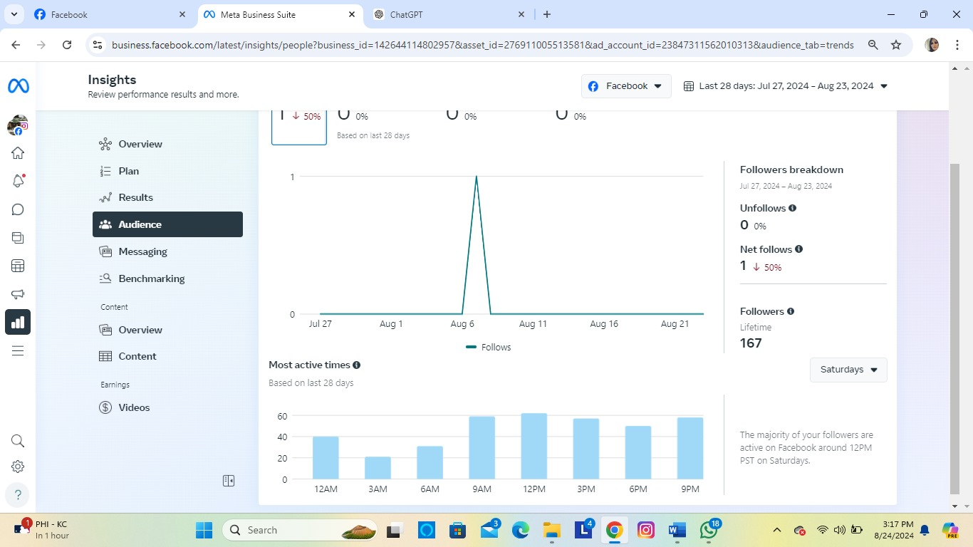

# Weekly Planner



|  |  |
| --- | --- |
|  |  |
|  |  |
|  |  |
|  |  |
|  |  |
| **AUDIENCE INTREST POSTS** |  |

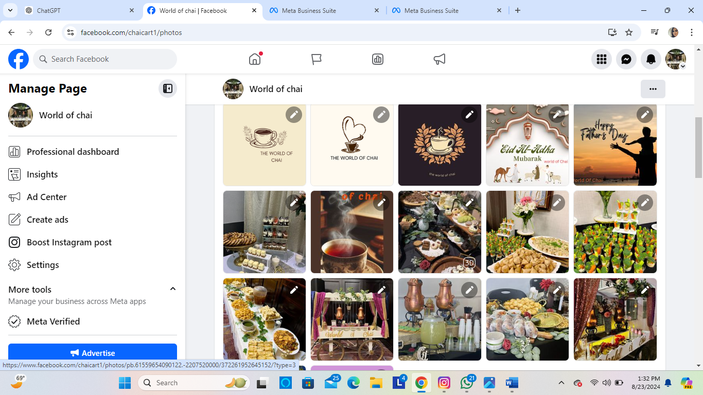

**AD Campaign**

**1. Identify Your Target Audience:**

* **Demographics:** Age, gender, location, income, education, etc.
* **Psychographics:** Interests, values, lifestyle, behaviors, etc.
* **Personas:** Create detailed profiles of your ideal customers.

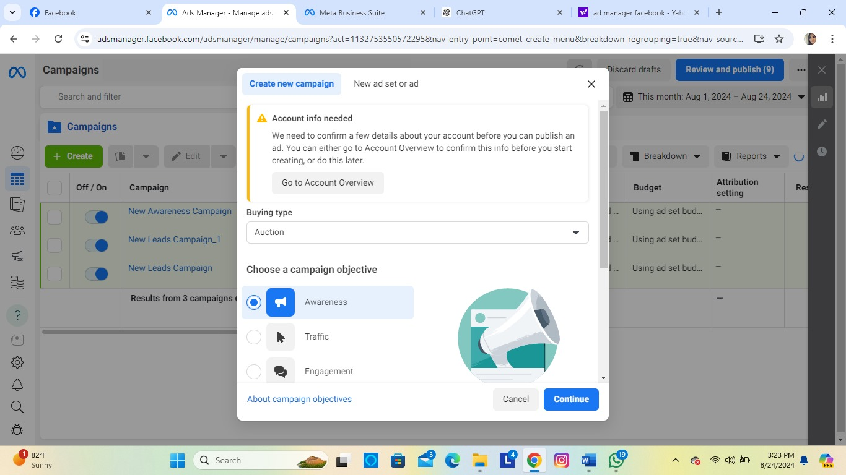

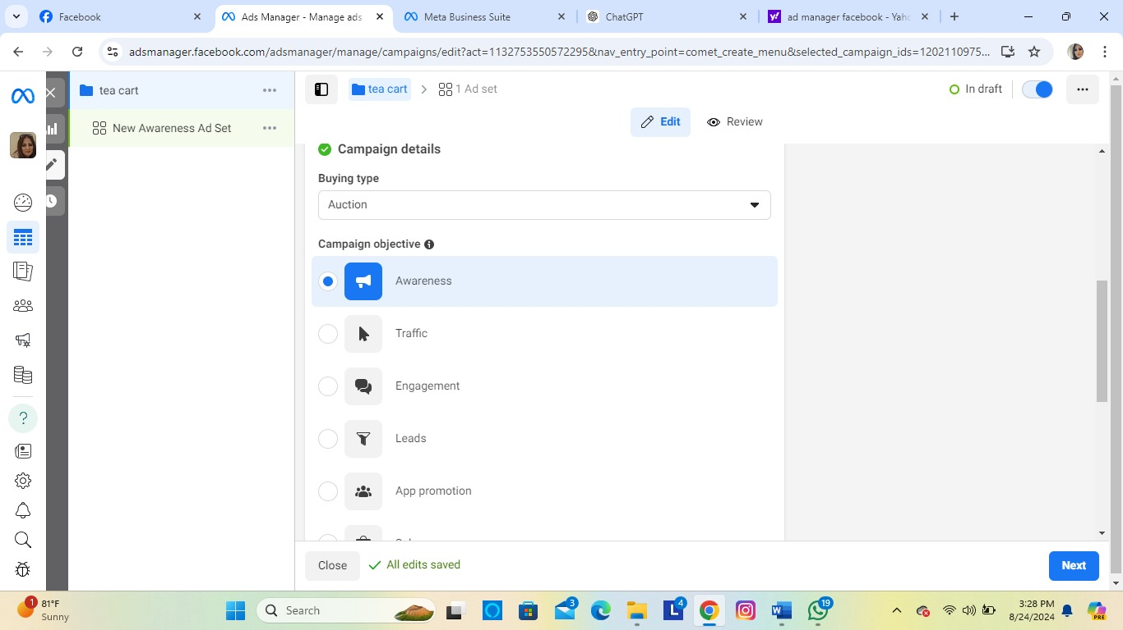

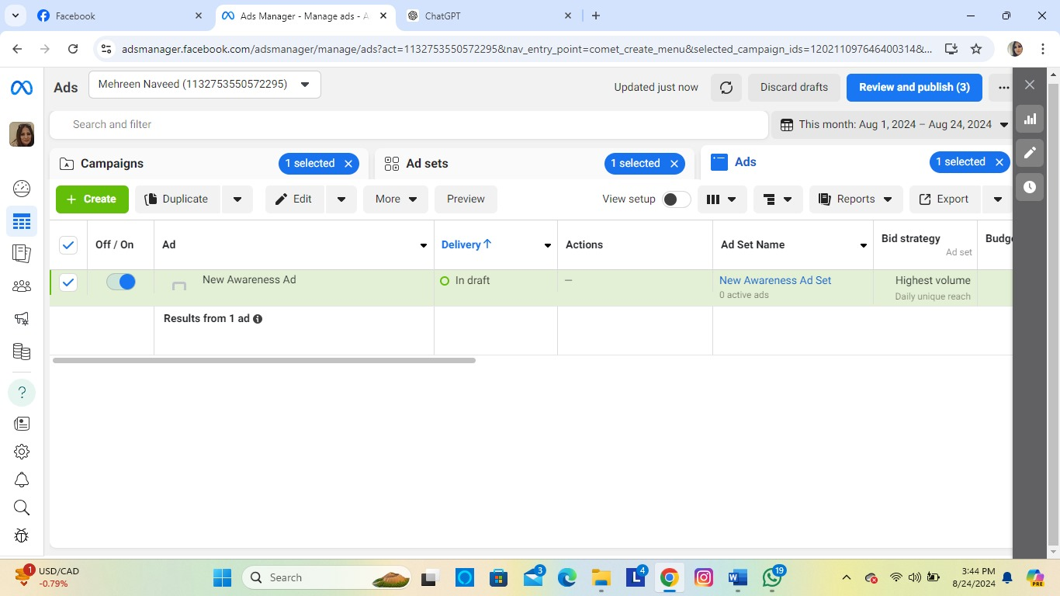

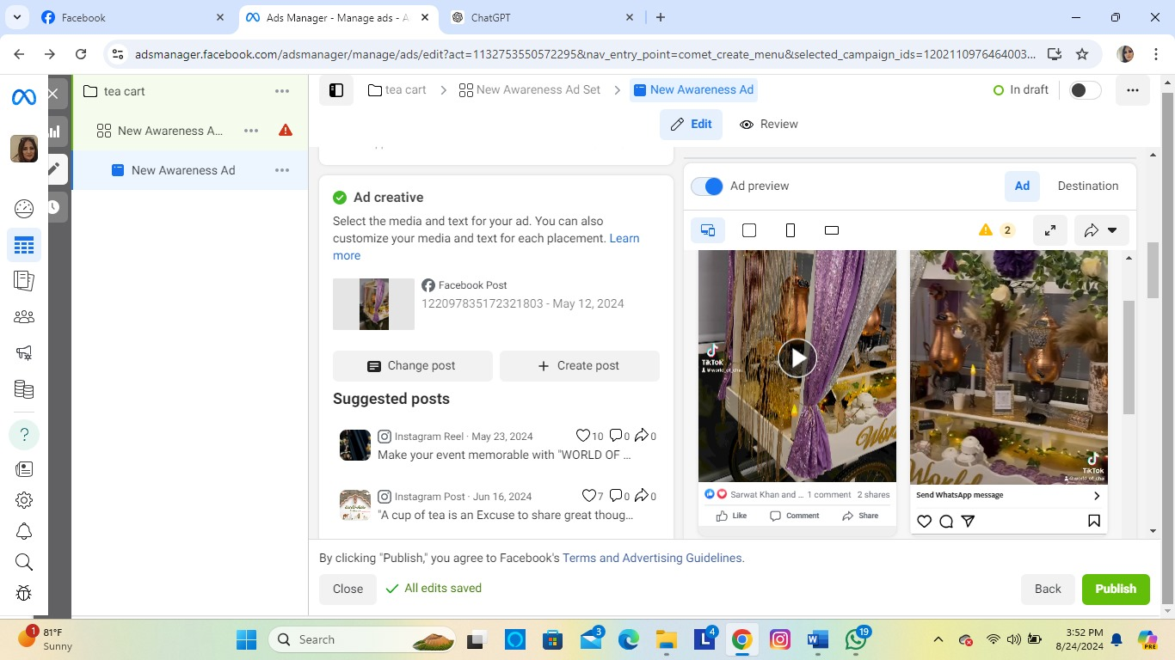

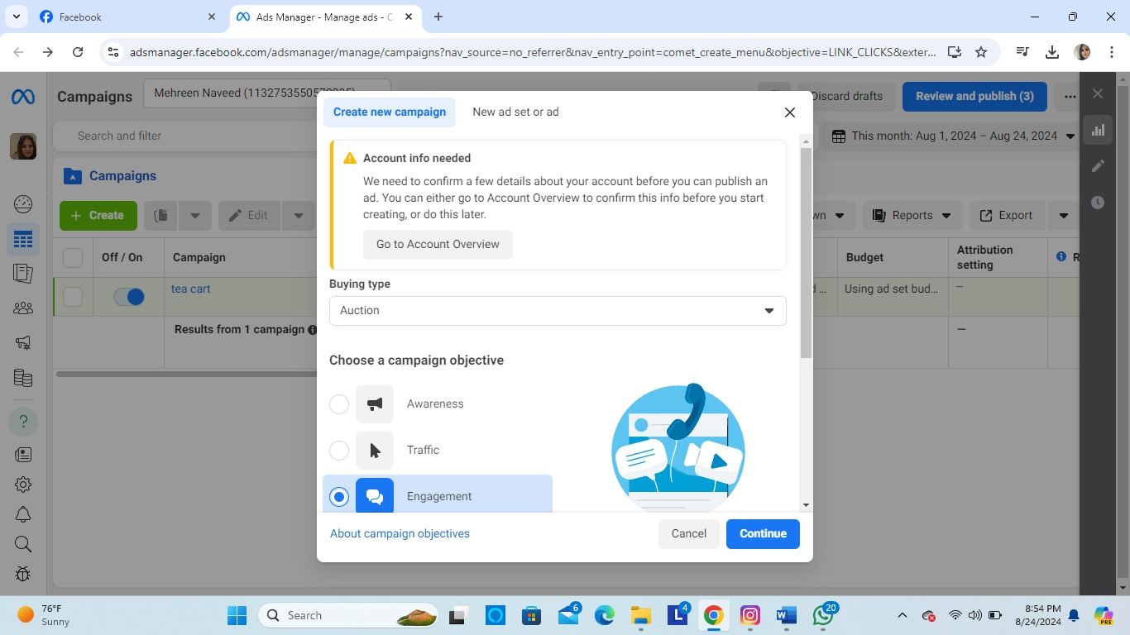

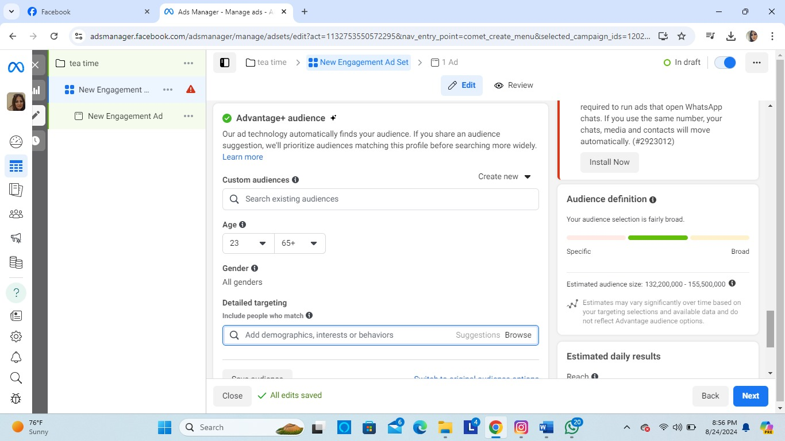

**Frequently asked Questions**

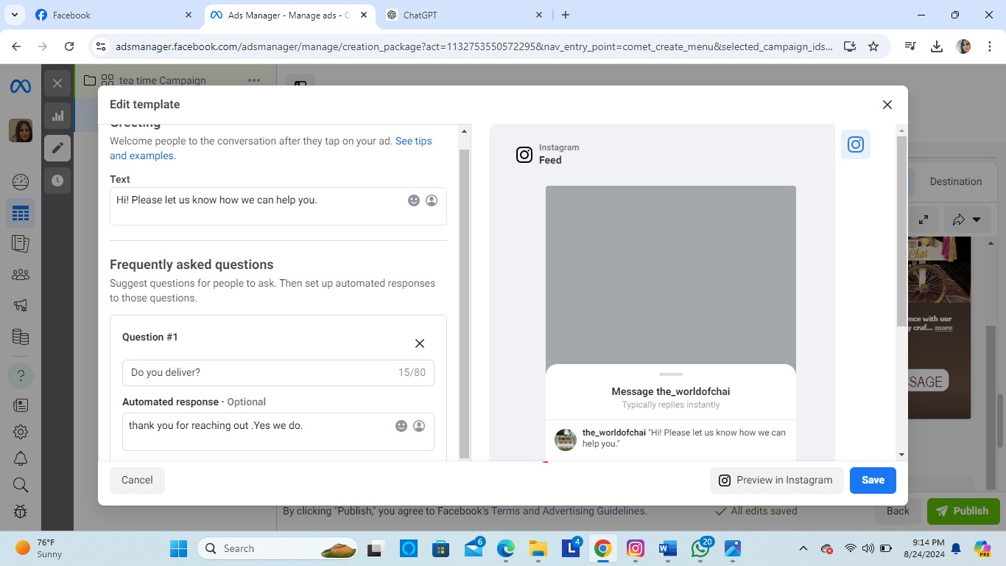

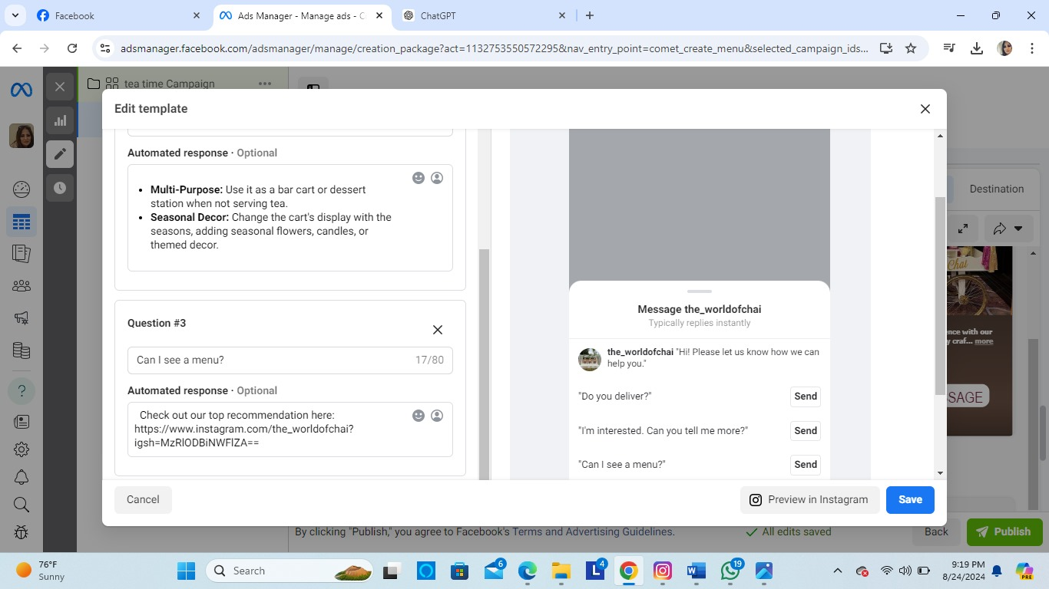

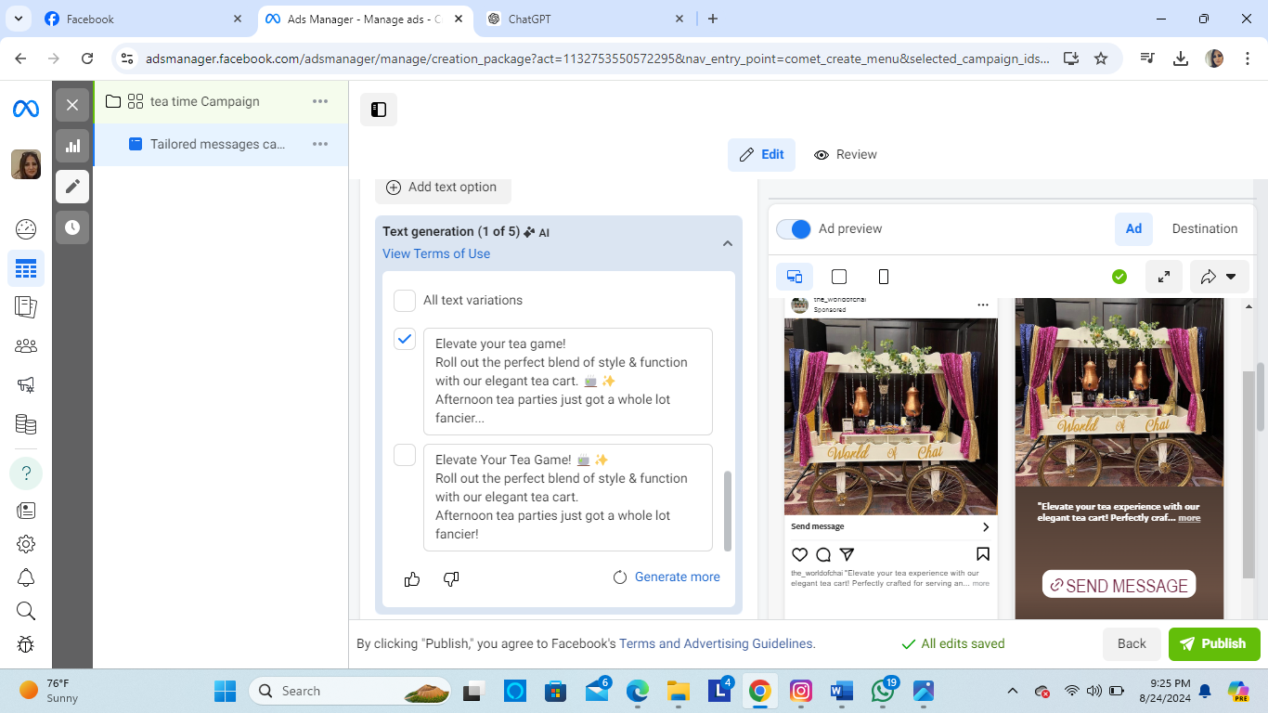

# Funnel

1: **What do you want to achieve?**

Identify your target audience

Create Awareness

**2. Create Awareness**

**Facebook/Instagram Ads**

Content Strategy

3. **Generate Interest**

**Engaging Content**

Lead Magnets

Retargeting Ads

4. **Nurture Leads**

Email Marketing

Custom Audiences

Engagement

5. **Convert Leads**

Strong CTA

Landing Pages

Offer Incentives

**6.Analyze and Optimize**

Track Performance

A/B Testing

Adjust Strategy

**7.Example Funnel Stages**

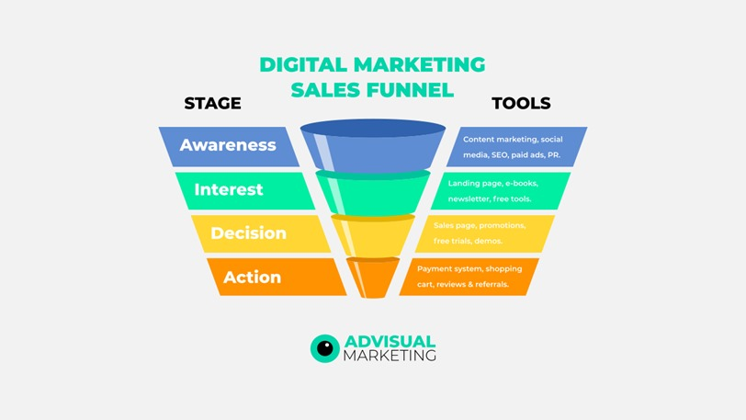

# INSTAGRAM

[World Of Chai (@the_worldofchai) Instagram photos and videos](https://www.instagram.com/the_worldofchai/)

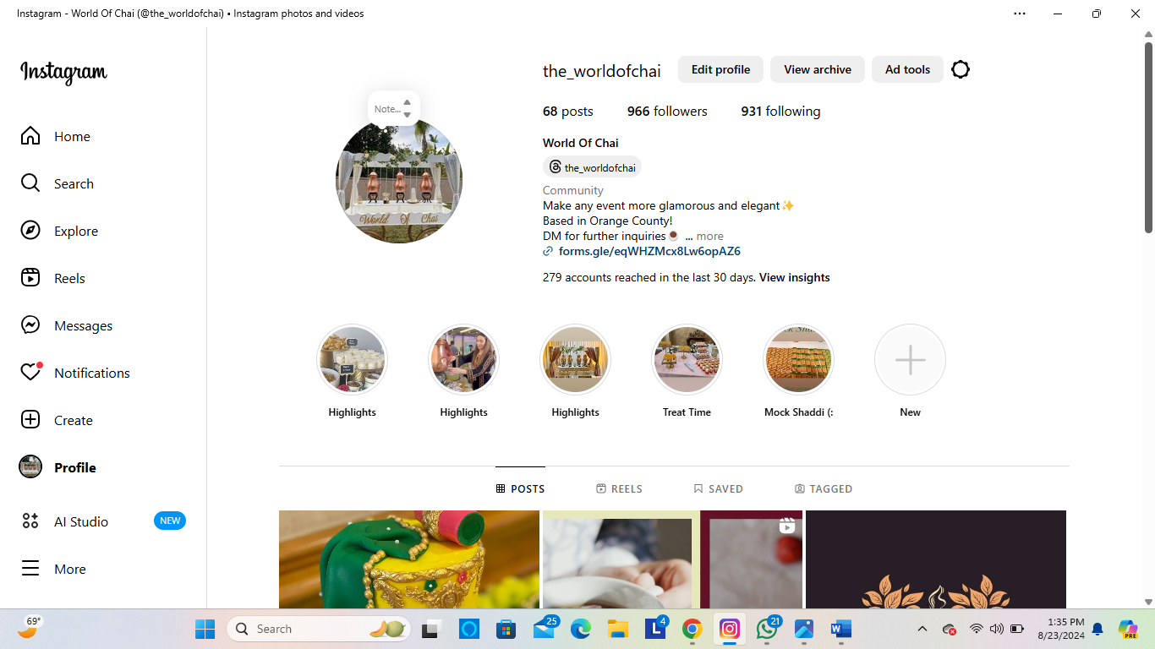

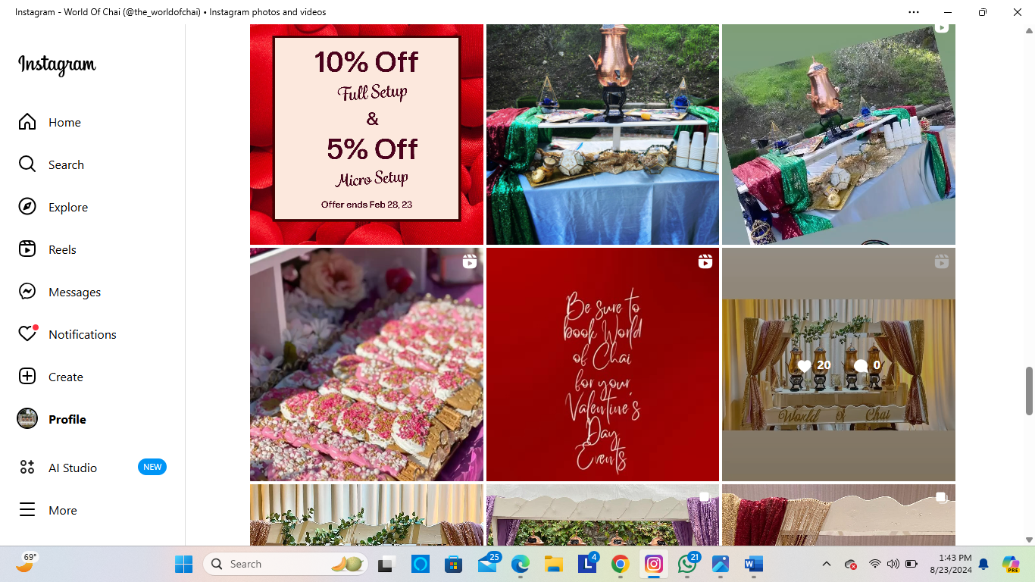

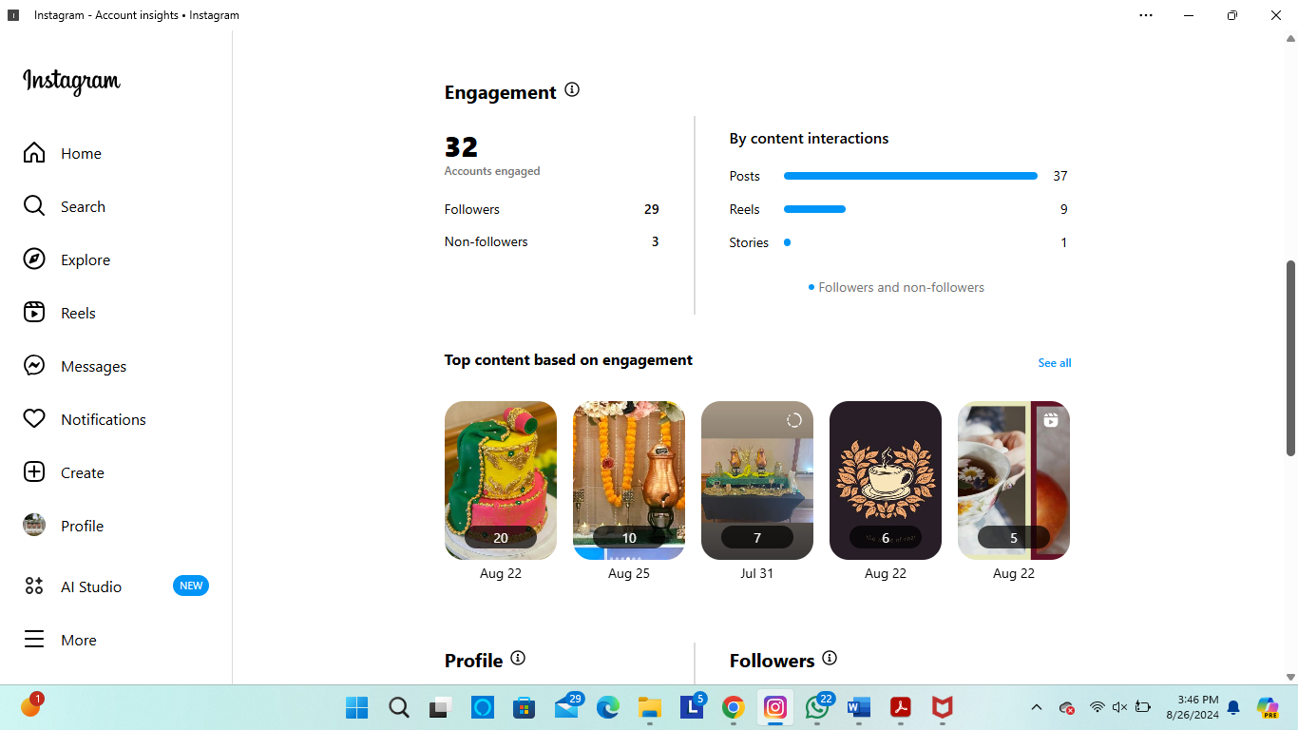

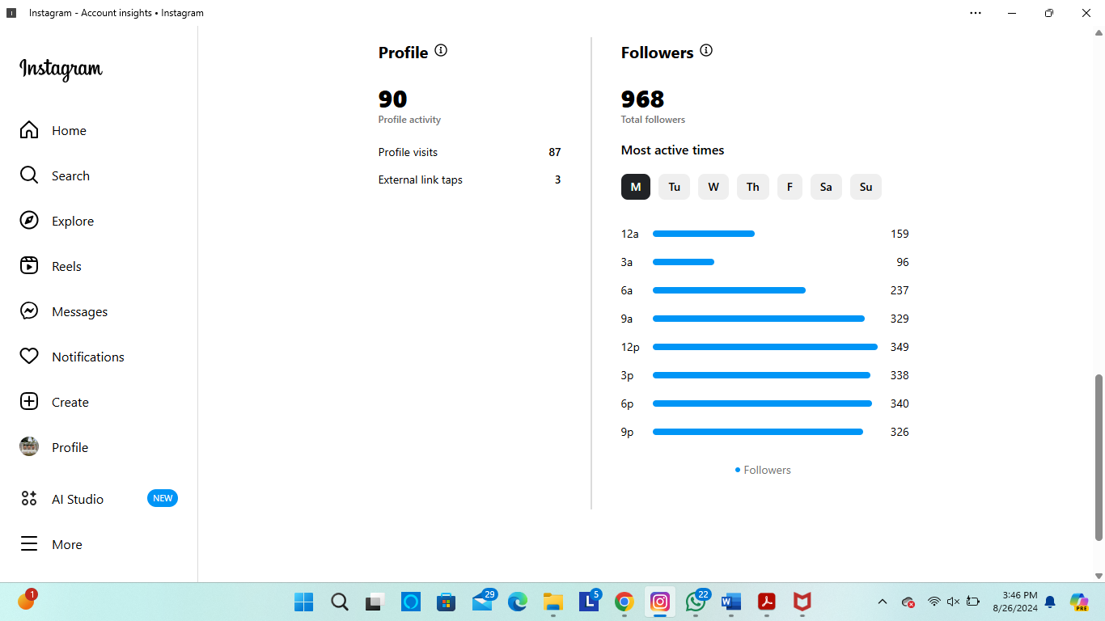

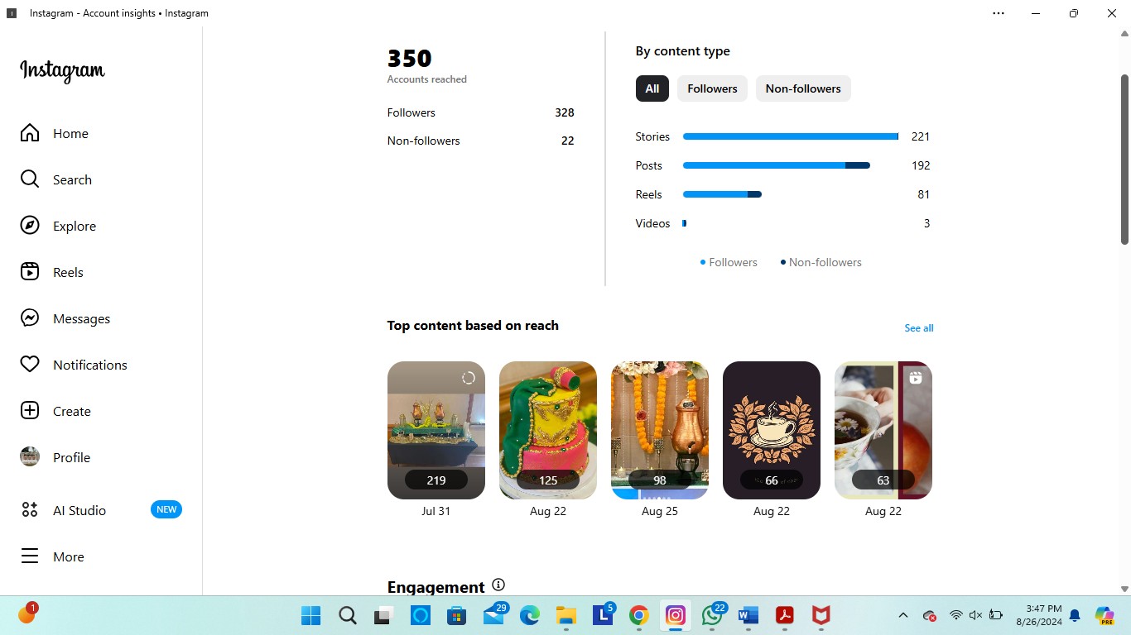

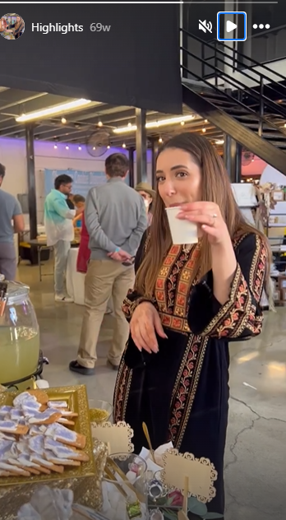

* **DISCOUNT OFFERS**



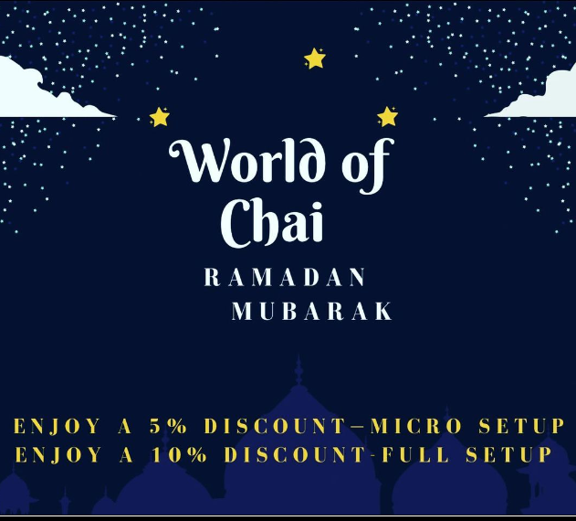

**Online profile (Linktree)**

